**RemotWatch Plug-In Manual to QGIS**

**version 1.0**

 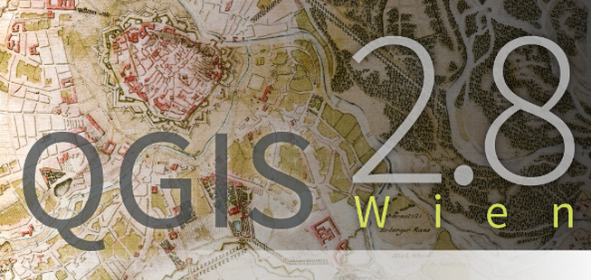

Joaquim J. Sousa(1), António M. R. Sousa(1), Luís Magalhães(1), Antonio M. Ruiz(2) , Pedro Guimarães (1,3)

August 2015

|  |
| --- |
| **RemotWatch Plug-In** was developed and tested using QGIS Desktop 2.8.2®  This version is only prepared for viStaMPS and SARPROZ processing results. |

|  |
| --- |
| **Publications that contain figures produced by the QGIS Desktop 2.8.2® software should contain an acknowledgment. [For example: This figure was generated using QGIS Desktop 2.8.2 with RemotWatch Plug-In (Sousa *et al.*, 2015)].** |

(1) University of Trás-os-Montes and Alto Douro ([www.home.utad.pt](http://www.home.utad.pt))

Science and Technology School, Engineering Department

Apartado 1013, 5001-081 Vila Real, PORTUGAL

(2) University of Jaén, Spain

Centro de Estudios Avanzados en Ciencias de la Tierra



(1,3) Polytechnic of Porto

School of Engineering, Physics Department

Rua Dr. António Bernardino de Almeida, 431, 4200-072 Porto, Portugal

**Contents**

**A. Installation/Configuration** 3

A.1. Download RemotWatch Plug-In package 3

**B. Requirements** 5

**C. Files/scripts included in viStaMPS package** 6

D. Files/scripts included in pstimeseries Plug-In package........................................................................ 6

**1. Introduction** 7

**2. Getting started with RemotWatch Plug-In** 8

2.1. Select File 8

2.2. Filter points and Show Layer 9

2.3. Plot Contour 10

2.4. Time Series Plot 12

**3. Future work** 13

**4. Conditions of use** 14

**5. Change History** 14

**Bibliography** 15

A. Installation/Configuration

A.1. Download RemotWatch Plug-In package

***a)*** Download and extract RemotWatch.rar inside \.qgis2\python\plugins QGIS folder;

***b)*** Download and extract pstimeseries.rar inside \.qgis2\python\plugins QGIS folder;

|  |
| --- |
| In the windows® the \.qgis2\python\plugins QGIS folder it is in the C:\Users\name_of_user\.qgis2\python\plugins folder |

***c)*** Open QGIS Desktop 2.8.2® (see Figure 1);

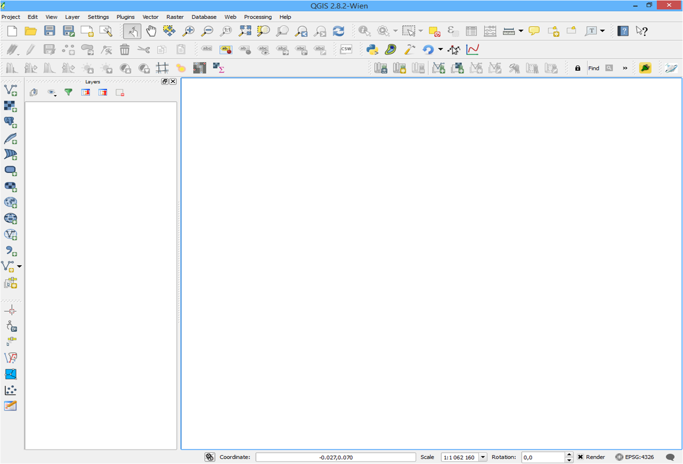

**Figure 1:** QGIS Desktop 2.8.2® Window.

***d)*** Open QGIS. Click on Plugins ‣ Manage and Install Plugins.... to open the Plugin Manager dialog; Click on the Settings tab. You will see an option called Show also experimental plugins. Click the checkbox next to it, to enable it. (see Figure 2).

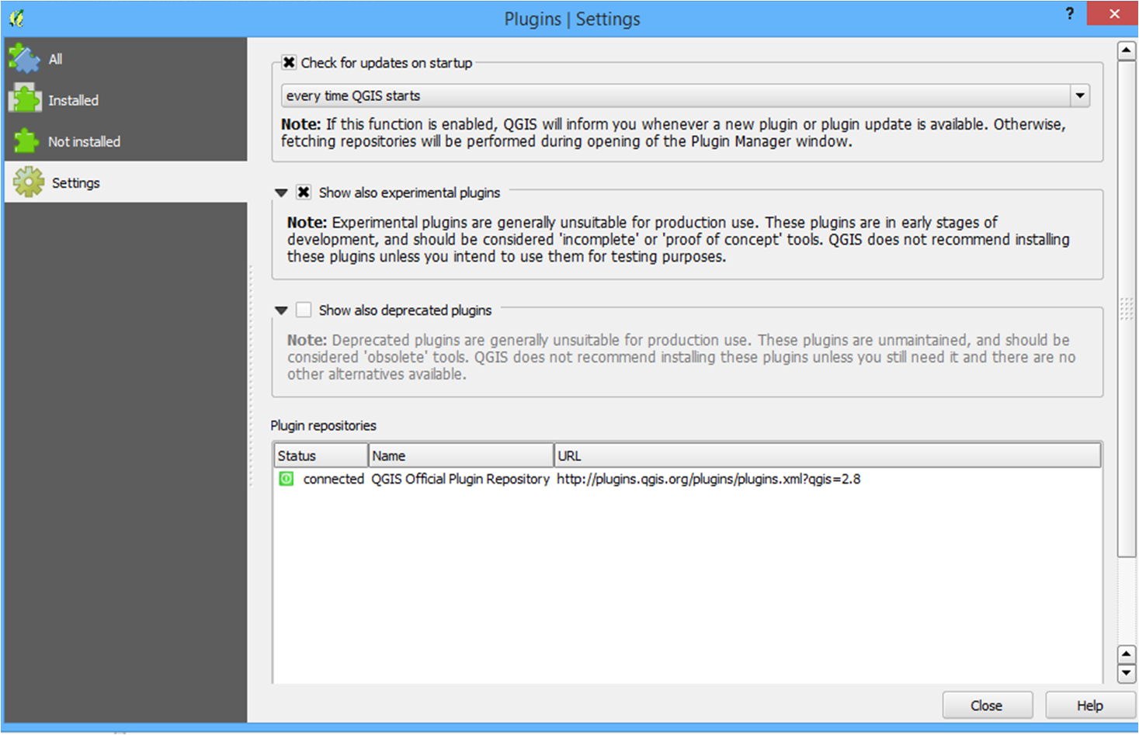  
**Figure 2:** Enable experimental plugins.

***e)*** In the search text box write RemotWatch (see Figure 3). Check on the checkbox next to RemotWatch Plugin. This will enable the plugin ;

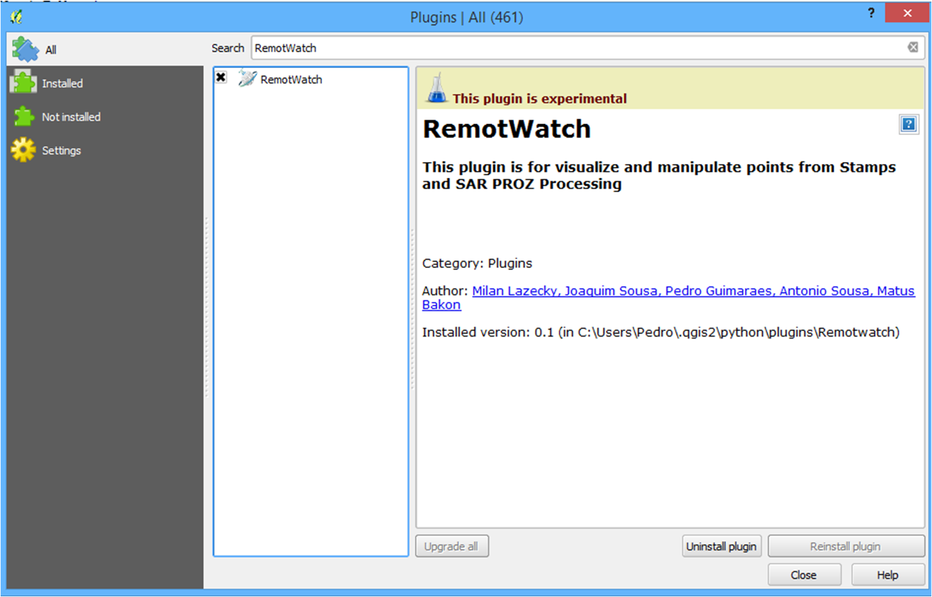  
**Figure 3:** Enable RemotWatch Plugin.

***f)*** Repeat the same for **Contour plugin** and **PS Time Series Viewer**.

***g)*** Now that the **RemotWatch**, **Contour plugin** and **PS Time Series Viewer** Plugin are enabled. You can go to the Plugins ‣ RemotWatch ‣ StaMPs and SAR-PROZ to use the functionality added by the plugin (see Figure 4); It also installed a button on the Plugins toolbar. You can also use this button to access the plugin

***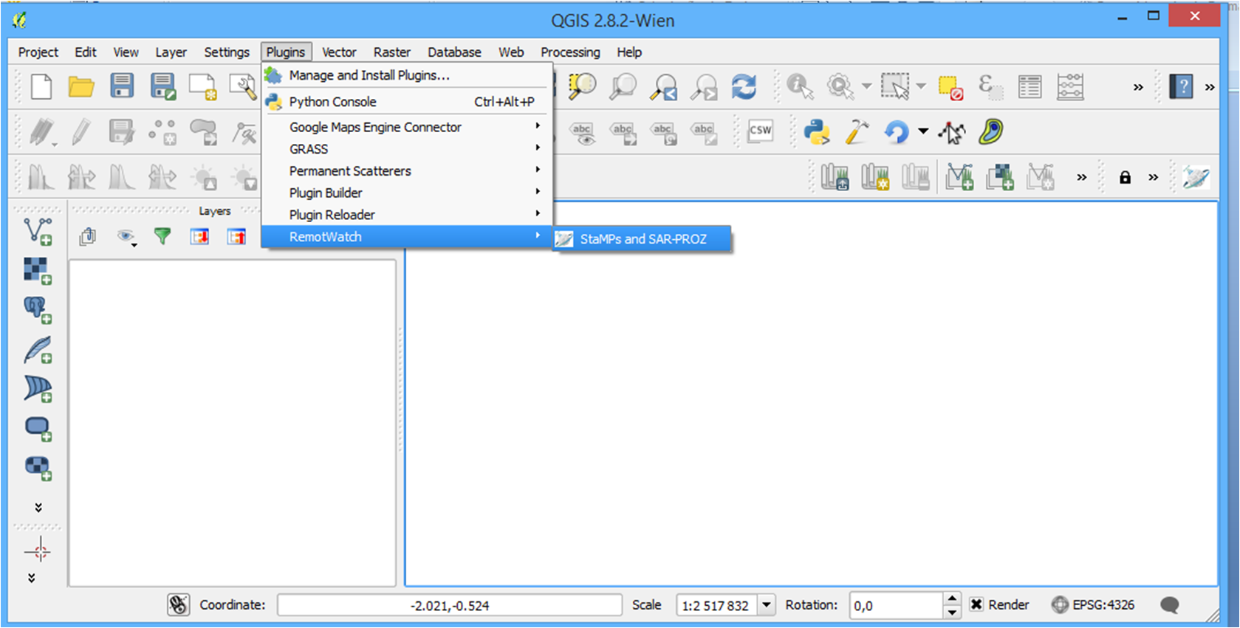*Figure 4:** Enable RemotWatch Plugin.

***h)*** Make sure that the **Contour plugin** and **PS Time Series Viewer** are installed (see Figure 5); m

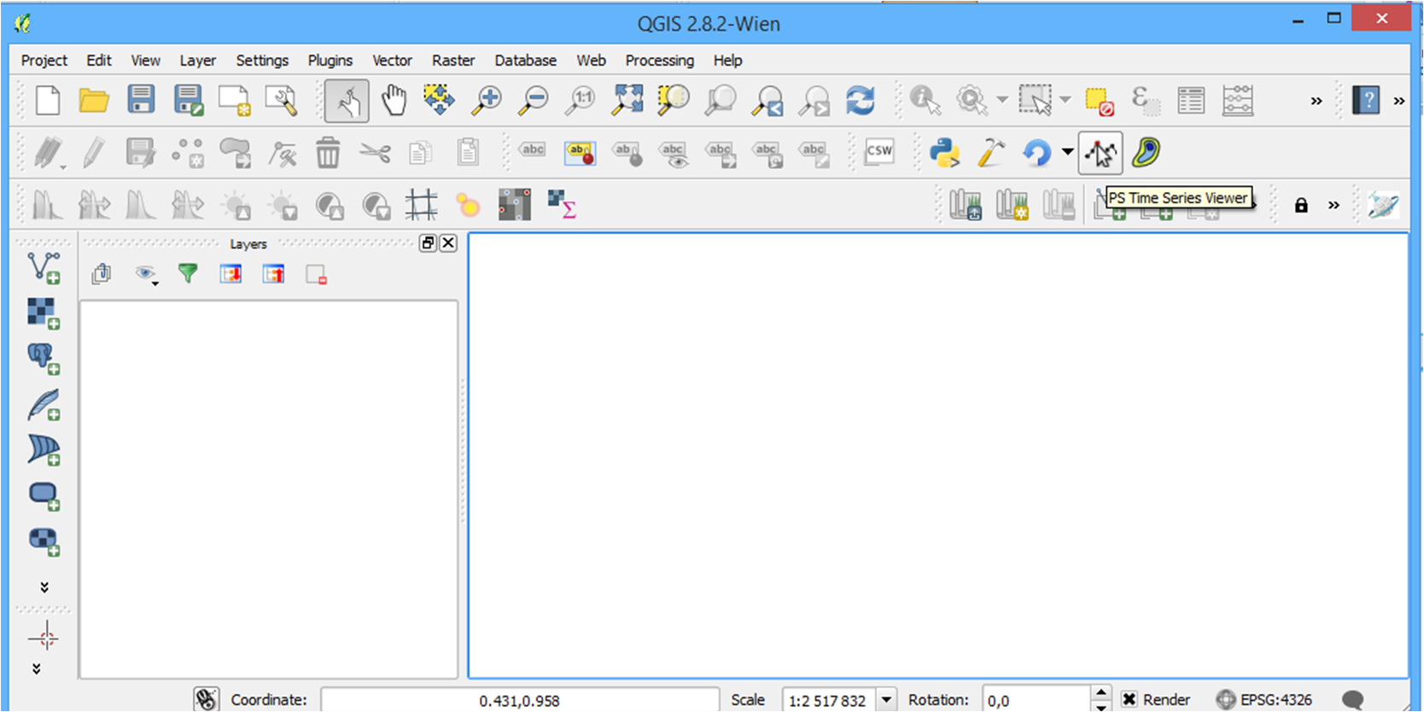**Figure 5:** Enable Contour plugin and PS Time Series Viewer plugin.

B. Requirements

RemotWatch Plug-In requires QGIS Desktop 2.8.2® and core plugins that are already part of the standard QGIS installation

|  |
| --- |
| All the tests performed in the development of this project were done using a 2.53 GHz Intel CoreTM 2 Duo processor and 4 GB of RAM memory. The computational aspects depend, of course, on the total number of PS, coherence and deformation thresholds applied. |

C. Files/scripts included in RemotWatch Plug-In package

|  |  |
| --- | --- |
| **Script/figure name** | **Brief description** |
| __init__.py | Script that checks if the initial files and parameters already exists in the Remotwatch folder. If not, all the necessary data will be created. |
| metadata.txt | The metadata file contains information about the plugin, including the name, description, version, icon, and minimum QGIS version. |
| resources.qrc | Describes resources used by the plugin and its GUI forms. |
| remot_watch.py | The main implementation of Remotwatch that handles loading, unloading, and execution of the plugin’s functions |
| remot_watch_dialog_base.ui | The GUI interface file created by Qt Designer. |
| start_rwt.py | The start_rwt file contains functions of the Remotwatch plugin |

D. Files/scripts included in pstimeseries Plug-In package

|  |  |
| --- | --- |
| **Script/figure name** | **Brief description** |
| **pstimeseries_plugin.py** | Adapted from pstimeseries plugin for Remotwatch plugin results |

1. Introduction

This manual provides a guide to running **RemotWatch** Plug-In, which is made available for non-commercial applications only.

Due to its proven reliability and freeware distribution among the scientific community, **Sta**nford **M**ethod for **P**ersistent **S**catterers (**StaMPS**) InSAR implementation (Hooper *et al.*,2004; Hooper *et al.*, 2007, and Hooper, 2008),

SARPROZ (Perissin, 2015)

**RemotWatch** Plug-In is a new visual application developed to enhance the visualization, manipulation and exportation of StaMPS and SARPROZ results and is an open-source project. The programmed application is written and developed in Python language through the Graphical User Interface (GUI) and no coding is required for running it, which avoids any programming language knowledge for standard uses.

This tool integrates fully new features together with various scripts from StaMPS, allowing the generation of the desired plots/maps in a user-friendly interface. It is done by simply clicking some buttons or changing some parameters located in visual panels, instead of input commands in a prompt. Moreover, since it is written in Matlab, it gives the users the opportunity to access the data very easily and make their own modifications.

2. Getting started with RemotWatch Plug-In

Figure 6 presents the RemotWatch Plug-In main window, which is divided in two main areas: **A** (Select File) and **B** ( Filter points and show layers).

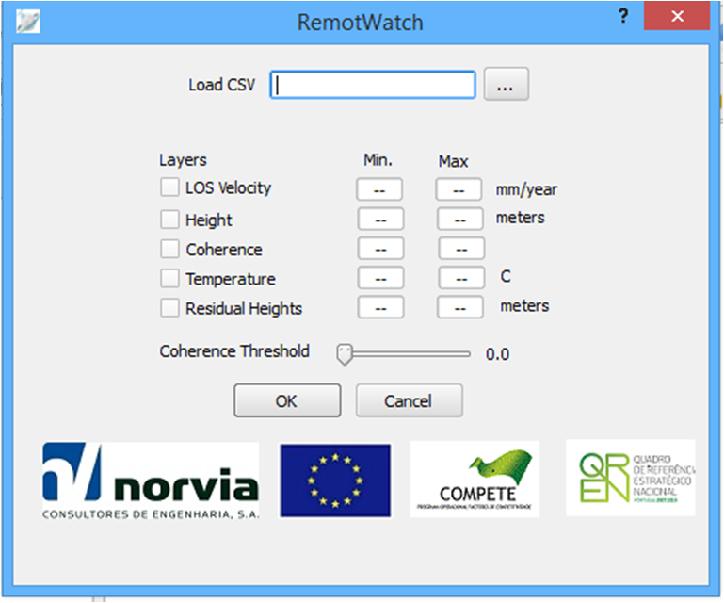

B

A

**Figure 6:** RemotWatch Plug-In main window.

2.1. Select File

RemotWatch Select File section is composed by one button (...) as shown in Figure 6.

Before starting it is mandatory choose the CSV file previously processed in StaMPS and SARPROZ by pressing the ... button

Follow the instructions below for select file:

**1.** Browse to the desired project folder (StaMPS or SARPROZ);

**2.** Choose the CSV File. They are collected all data of CSV file and are filled in all the available fields as shown in Figure 7.

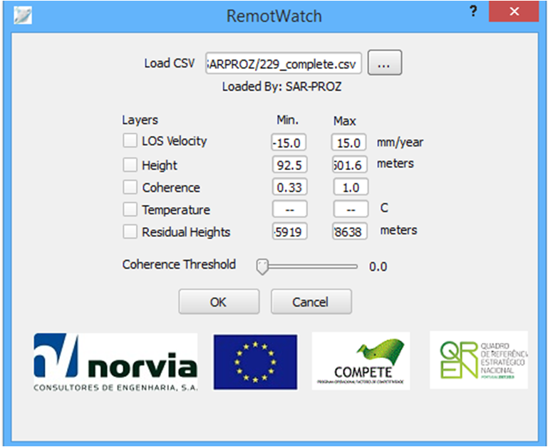  
**Figure 7:** Fill all available fields from SARPROZ CSV file

2.2. Filter points and Show Layer

After fill all available fields it possible filter points and show selected layers. As shown in Figure 8 , after press OK button will be created two layers (LOS Velocity and Height) with points with Coherence Threshold with 0.86 .

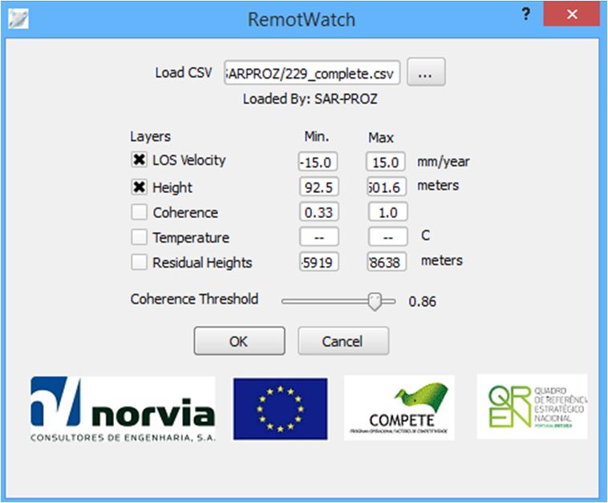

**Figure 8:** Available options for Filter Points and selected layers.

After press OK button the QGIS Desktop 2.8.2® produces two layers with the filter points as shown in Figure 9

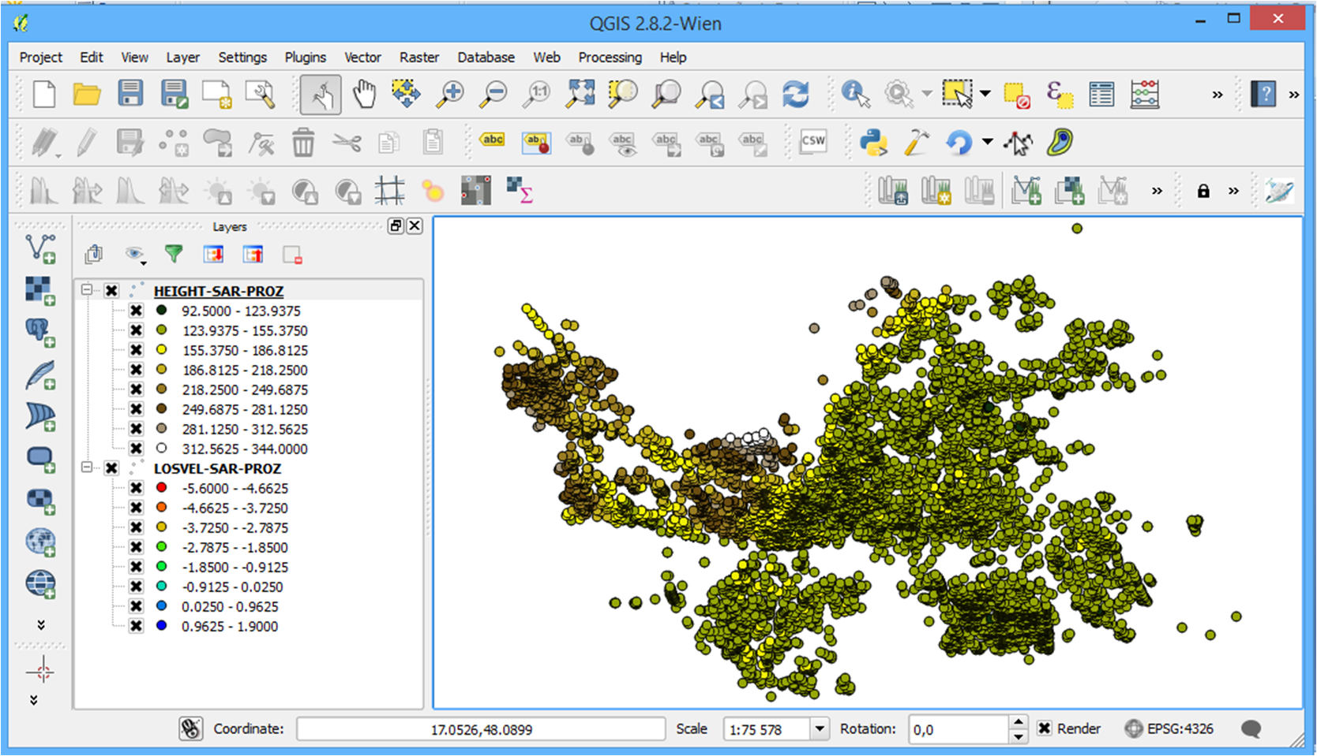 **Figure 9:** LOS Velocity and Height layer produces by QGIS Desktop 2.8.2®

In QGIS Desktop 2.8.2® it possible hide and remove layers if desired with available tools.

2.3. Plot Contour

QGIS Desktop 2.8.2 allow draw a border that will be used to create contours maps in a desired/interested area.

For plot contour maps follow the instructions below:

**1.** Select the layer do you want see the contour map (Figure 10);

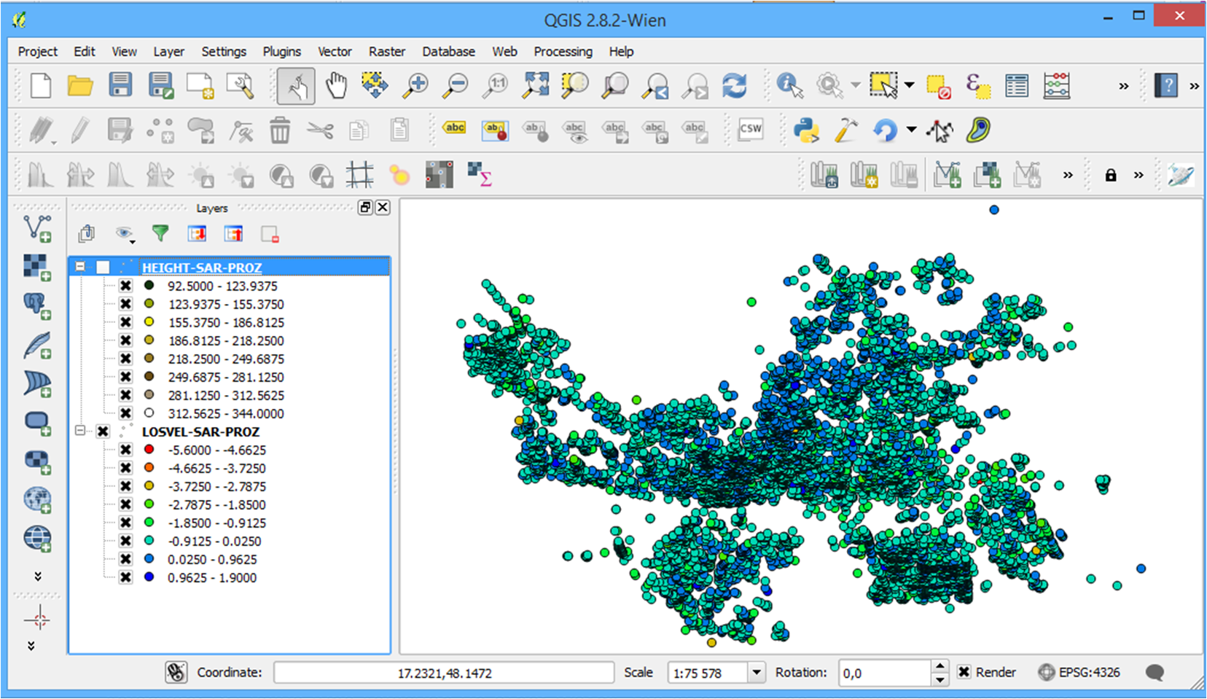  
**Figure 10:** Select LOS Velocity and hide Height layer produces by QGIS Desktop 2.8.2®

**2.** Draw borders manually in the layers with the Select Features by area or single click tool (Figure 11) available in QGIS Desktop 2.8.2®

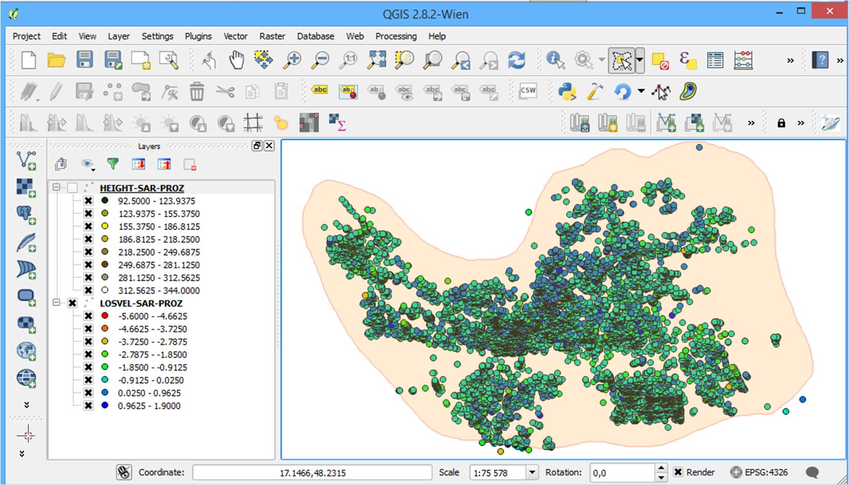  
**Figure 11:** Draw borders manually in QGIS Desktop 2.8.2®

**3.** After defining an interested area it is possible to generate the contour map. To do this you must select the Contour tool previously installed(Figure 12).

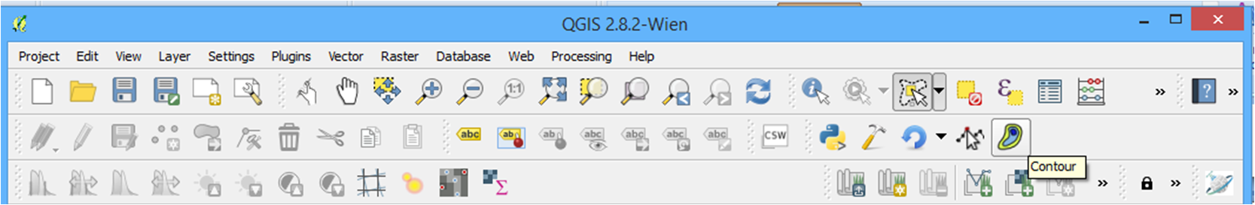  
**Figure 12:** Select contour tool for creat contour maps

**4.** A window appears. Here you should define the Vector Layer and the Data Filed for the map, You can also define some contouring properties and the colors of contours (Figure 13).

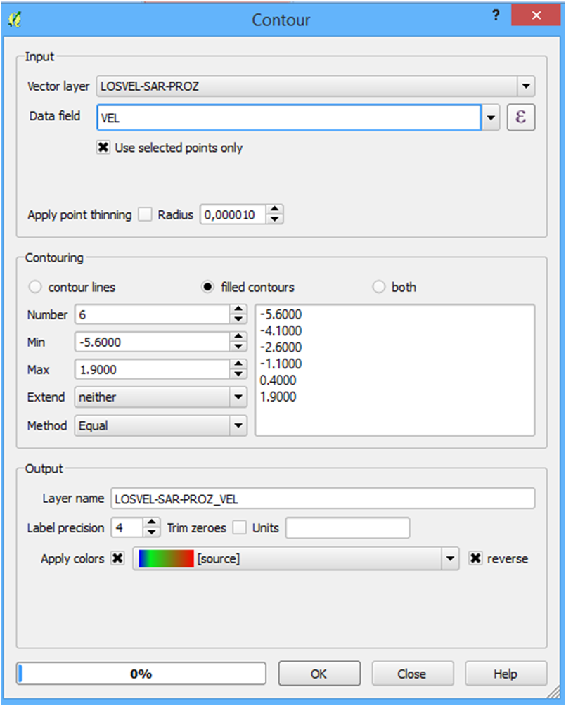  
**Figure 13:** Contour Window tool

**4.** Finally, a contour map is generated (Figure 14).

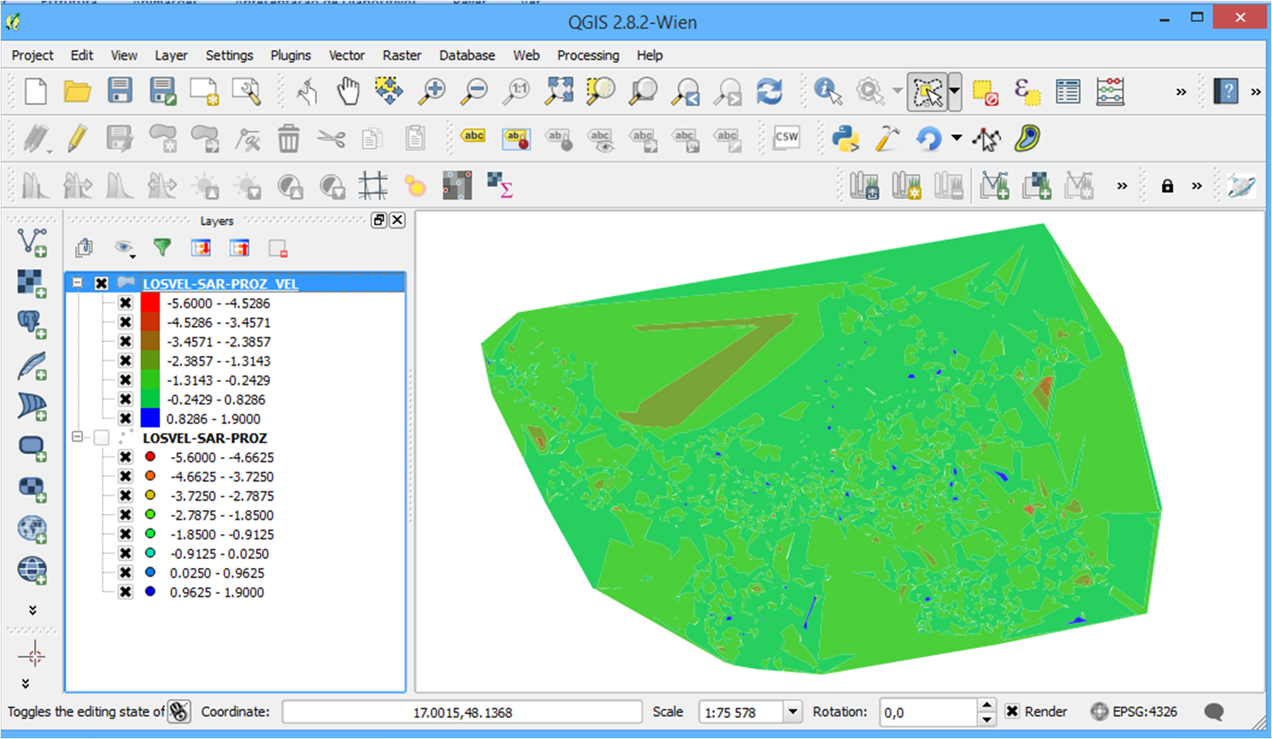  
**Figure 14:** Contour map generated

2.4. Time Series Plot

Time series plot is another interesting output that helps in the analysis and interpretation of results, since it describes the evolution of displacement over the entire analyzed period. In QGIS, time series plots can be visualized by simply picking a point from the laye. The resulting plots will reﬂect the RemotWatch parameters used for plotting the deformation map.

For plot a Time Series of a point we used the plugin pstimeseries previously installed. This plugin is adapted to support the data type from the RemotWatch processing.

The steps presented below must to be followed for use the tool of Time Series:

**1.** Press PS Time Series Viewer a Polygon icon (Figure 15).

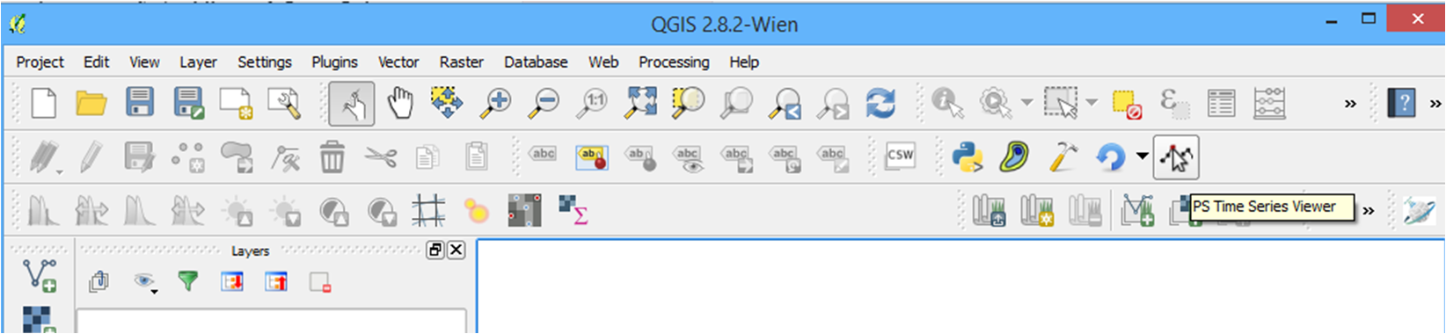

**Figure 15:** Time series plot interface

**2.** Pick a point in the select layer;

**3.** In Figure 16 we can see the window that appears.

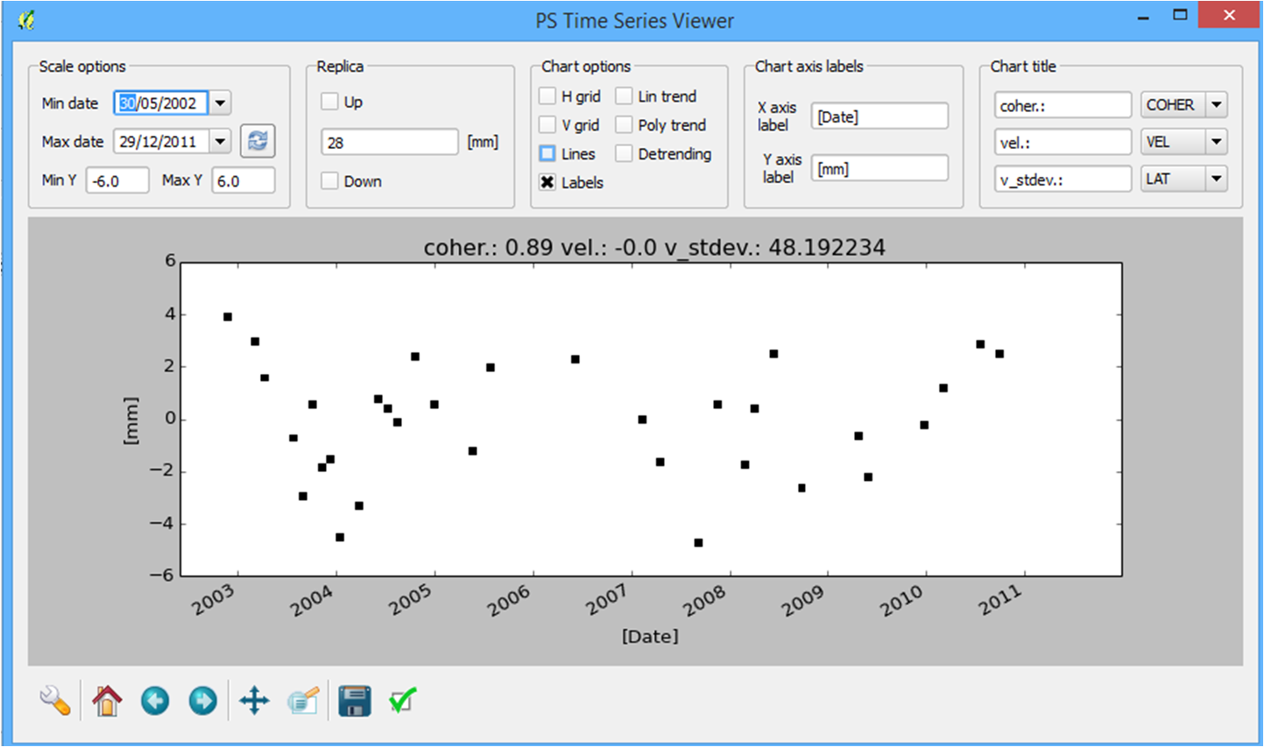  
**Figure 16:** Time series plot interface

**4.** This interface has a set of display features of the time series you can change as shown in Figure 17

**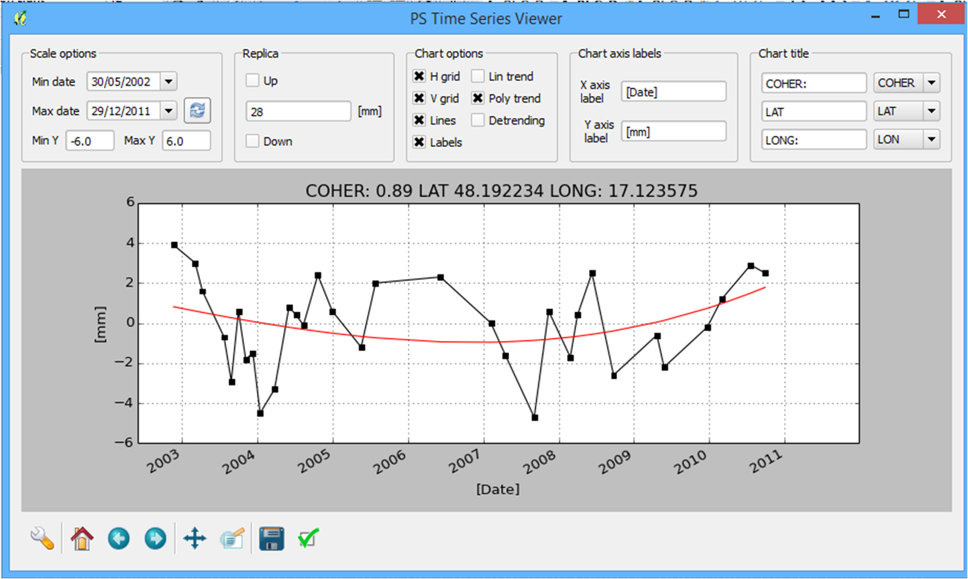  
Figure 17:** Some plot features in Time series plot interface

It is possible to fit the time series to distinct deformation regimes, depending on the causes and type of the deformation and also restrict the time series range.

3. Future work

4. Conditions of use

The conditions of use are as follows:

5. Change History

5.1. Version 1.0 (August 2015)

* Initial beta release ;

Bibliography

Hanssen, R. F. (2001). Radar interferometry: Data interpretation and error analysis. Dordrecht: Kluwer Academic Publishers 2001.

Hooper, A., Zebker, H., Segall, P., Kampes, B., 2004. A new method for measuring deformation on volcanoes and other natural terrains using InSAR persistent scatterers. Geophysical Research Letters 31, L23611.

Hooper, A., Segall, P., Zebker, H., 2007. Persistent Scatterer InSAR for Crustal Deformation Analysis, with Application to Volcán Alcedo, Galápagos, Journal Geophysical Research,, 112, B07407, doi:10.1029/2006JB004763.

Hooper, A., 2008. A multi-temporal InSAR method incorporating both persistent scatterer and small baseline approaches. Geophysical Research Letters 35, L16302.

D. Perissin and T. Wang, 2012. Repeat-pass SAR Interferometry with Partially Coherent Targets, IEEE Transactions on Geoscience and Remote Sensing, page(s): 271-280, Volume: 50 Issue: 1, Jan. 2012.

Sousa, J. J., Magalhães, L. M., Ruiz, A. M., Sousa, A. M. R. and Cardoso, G. (2013): The viStaMPS tool for visualization and manipulation of time series interferometric results, series interferometric results, Comput. Geosci., 52, 409–421, doi:10.1016/j.cageo.2012.11.012.

D. Perissin, SARPROZ Software. Official Webpage: www.sarproz.com (2015)